True Usage  
A PROJECT REPORT  
BY  
TEAM NO. 8  
  
  
  
Team Members  
  
Amitosh Tripathi (E23CSEU1614)  
Aditya Sirohi (E23CSE1619)  
Ayush Kushwaha (E23CSE1592)  
Vikhyat Baliyan (E23CSEU1596)  
   
  
  
  
SUBMITTED TO  
  
  
  
  
  
SCHOOL OF COMPUTER SCIENCE ENGINEERING AND TECHNOLOGY, BENNETT UNIVERSITY  
GREATER NOIDA, 201310, UTTAR PRADESH, INDIA  
  
   
April 2025

DECLARATION  
  
I/We hereby declare that the work which is being presented in the report entitled “True Usage”, is an authentic record of my/our own work carried out during the period from JAN, 2025 to April, 2025 at School of Computer Science and Engineering and Technology, Bennett University Greater Noida.  
The matters and the results presented in this report has not been submitted by me/us for the award of any other degree elsewhere.  
  
  
Signature of Candidate--  
  
 Amitosh Tripathi  
(Enroll. No. E23CSEU1614)  
  
  
Aditya Sirohi  
(Enroll. No. E23CSEU1619)  
  
  
Ayush Kushwaha  
(Enroll. No. E23CSEU1592)  
  
  
Vikhyat Baliyan  
(Enroll. No. E23CSEU1596)

**ACKNOWLEDGEMENT**

I/We would like to take this opportunity to express my/our deepest gratitude to my/our mentor, Mrs. Riti Kushwaha for guiding, supporting, and helping me/us in every possible way. I/we was/were extremely fortunate to have him as my/our mentor as he provided insightful solutions to problems faced by me/us thus contributing immensely towards the completion of this capstone project. I/We would also like to express my/our deepest gratitude to VC, DEAN, HOD, faculty members and friends who helped me/us in successful completion of this capstone project.

Name of Teammate1 : Amitosh Tripathi  
(Enroll. No. E23cseu1614)  
 Name of Teammate2 : Aditya Sirohi  
(Enroll. No. E23cseu1619)  
 Name of Teammate3 : Ayush Kushwaha  
(Enroll. No. E23cseu1592)  
Name of Teammate4 : Vikhyat Baliyan  
(Enroll. No. E23cseu1596)

**Abstract**As warranty fraud continues to cause revenue losses and operational delays for manufacturers, the need for a robust and automated timestamp logging mechanism becomes more critical than ever.   
  
Our project introduces an innovative solution using an ESP32-based embedded system, fortified with RFID tagging and real-time timestamping via NTP servers. The key feature of this system is its ability to autonomously capture the product’s very first boot-up timestamp and store it in EEPROM memory, making it immutable and reliable.   
  
This data becomes a trustworthy point of reference for warranty validation, removing dependence on user inputs or purchase receipts. The inclusion of IoT features offers the potential for cloud syncing, thereby enhancing transparency and after-sales support. With its low cost, high scalability, and ease of deployment, this solution has the capacity to revolutionize product lifecycle tracking across various industries, especially for manufacturers looking to modernize their warranty validation process without complicating user experience.

**Introduction of Project**

In today’s competitive market, warranties are a symbol of trust and product assurance. However, the validation process often hinges on the user’s ability to preserve purchase receipts or register their devices, which introduces numerous opportunities for error or fraud. Our project presents a smart embedded system powered by the ESP32 microcontroller that removes the human element from this equation.   
  
By integrating RFID technology for product-specific tagging and NTP-based time synchronization, the system logs the exact moment a product is first powered on. This timestamp is then stored in non-volatile memory (EEPROM), making it persist through reboots and power cycles. The automation ensures that even if users fail to register their product or lose receipts, the activation date remains securely recorded. With the potential to scale to cloud-based dashboards, the system not only helps manufacturers keep accurate records but also enhances customer satisfaction by streamlining service eligibility checks.

**Related Work**

Many current systems rely on traditional methods such as receipts, barcodes, serial numbers, or user registration portals for warranty validation.   
  
These systems can be circumvented or manipulated, especially when relying on user honesty or centralized databases vulnerable to breaches. Premium devices sometimes include diagnostic chips or companion apps to track usage, but such setups are often expensive and complex. Our solution addresses these challenges with a simpler, cost-effective system that doesn’t require end-user participation.   
  
By automating the logging process at the hardware level using inexpensive components like RFID and ESP32, we provide a more secure and hands-free method for manufacturers to track and validate the first use of their products. This not only ensures better compliance with warranty policies but also protects the manufacturer’s bottom line.

**Problem Statement**  
The absence of a reliable and tamper-proof method for identifying the first use of an electronic product presents challenges for both customers and manufacturers.   
  
Consumers often lose receipts or fail to register products, which causes confusion and denial of service during warranty claims. On the manufacturer’s side, verifying the authenticity of a claim becomes difficult, sometimes resulting in fraud or unnecessary service expenses. Hence, a system is required that can independently log the product’s first-use timestamp, store it securely, and offer this information without relying on customer input.   
  
The logged data must be accurate, non-editable, and accessible across the product lifecycle, even in offline conditions.

**Requirement Analysis, Risk Analysis, Feasibility Analysis**  
*Requirements:* The core system comprises an ESP32 module with Wi-Fi capabilities, an RFID reader (RC522) to identify each product uniquely, a 16x2 LCD with I2C interface for user feedback, and EEPROM for permanent timestamp storage. Additional optional components include current or voltage sensors for power status tracking, and a cloud platform for data syncing.  
  
*Risk Analysis:* Potential risks include loss of Wi-Fi connectivity at the first boot, which may prevent time retrieval; EEPROM memory corruption; power loss during the write operation; or hardware failures. These risks can be mitigated using retry mechanisms for internet access, redundant memory operations, or integrating small UPS modules to handle power interruptions.  
  
*Feasibility:* Given the low cost and wide availability of components, the system is feasible for widespread deployment, especially among budget-conscious manufacturers. Software complexity is minimal, and the internet is only needed at first boot. This ensures ease of integration and operation.

**Proposed Solution or Approach or Technique**  
The proposed system ensures that each electronic product logs a secure and accurate timestamp during its first activation, using the ESP32 microcontroller’s internet connectivity and built-in EEPROM.   
  
Upon first power-up, the ESP32 automatically connects to a predefined Wi-Fi network and queries the current time from an NTP server. This timestamp is then stored in EEPROM and displayed on an LCD for local verification.   
  
Additionally, each unit is tagged with an RFID, ensuring unique identification. If cloud integration is enabled, the data can be uploaded to a centralized database for remote monitoring. The recorded timestamp acts as a lock-in point that remains fixed throughout the lifecycle of the product. This system guarantees automation, tamper-resistance, and ease of deployment without needing the user to perform any registration steps.

**Architecture Diagrams, Flow Charts, DFD**  
**Architecture:** RFID Tag → ESP32 Microcontroller → Wi-Fi Module → NTP Server → EEPROM Storage → LCD Display → Optional Cloud/API Sync → Manufacturer Dashboard.  
  
  
**Flow Chart:**

Device is powered ON  
Attempts to connect to Wi-Fi  
Queries time from NTP server  
Stores timestamp in EEPROM if not already stored  
Displays time on LCD  
Optionally syncs data to cloud API or dashboard  
  
  
**DFD:** User (Manufacturer) ↔ Embedded Device (ESP32) ↔ NTP Server ↔ EEPROM ↔ Cloud API ↔ Warranty Management Database

**Simulation Set up and Implementation**  
We used the Wokwi ESP32 simulator to develop and validate the system logic before implementing it with real hardware. The simulator allowed us to emulate the entire hardware setup, including RFID tags, LCD screens, and EEPROM operations.   
  
The ESP32 connects to a simulated Wi-Fi network, retrieves the exact time using NTP, and writes this timestamp into EEPROM memory. A virtual LCD module shows the status updates and confirms data logging. The simulation was particularly useful in testing retry mechanisms, EEPROM behavior, and network dependency.

Once validated, the code was transferred to actual hardware, ensuring consistency and functional reliability. In physical setups, RFID tags uniquely identify units, and the system is powered by USB or external sources.

**Result Comparison and Analysis**  
Tests conducted during simulation and physical implementation showed consistent performance in acquiring accurate time within two seconds of powering on.

Data persisted across multiple resets and was displayed clearly on the LCD screen. Compared to manual methods of warranty tracking that involve paperwork or human error, this automated system is faster, more reliable, and immune to manipulation.   
  
It simplifies customer experience by removing the need for user-side activation or submission. Cost comparisons show this system to be over 60% cheaper than diagnostic chips or companion app solutions.

The system's simplicity and autonomy stand out as strong advantages, especially for low to mid-tier manufacturers looking to enhance customer service while minimizing operational costs.

**Learning Outcome**  
This project enhanced our understanding of embedded systems and their application in real-world industry problems.

We gained experience in wireless communication using ESP32, time synchronization with NTP, EEPROM data handling, and hardware-software integration. Simulation skills improved via the Wokwi platform, while practical deployment taught us about hardware limitations and design challenges.   
  
We also learned to factor in risks and devise mitigation strategies. Furthermore, this project helped us understand how automation and data integrity can transform conventional workflows, providing critical thinking experience in designing systems that are both efficient and scalable.

These lessons are highly valuable for future projects involving IoT, cloud computing, and product lifecycle automation.

**Conclusion with Challenges**  
In conclusion, our system provides a practical and effective solution to one of the major pain points in electronics after-sales service—verifying the authenticity of warranty claims.

The autonomous logging of first-use timestamp eliminates the need for receipts, registration, or user inputs. This hands-free mechanism can be a game-changer for manufacturers and service centers alike.   
  
Challenges during the development phase included dependency on internet availability, handling EEPROM read/write operations, and simulating real-world RFID interactions. These were addressed through careful software design, redundant logic checks, and real-time debugging tools.

As future steps, the solution can be upgraded with encrypted cloud sync, real-time alerts, and integration with mobile apps or customer dashboards. With minor improvements, this system can evolve into a plug-and-play warranty validation module for a variety of products.

Flowchart

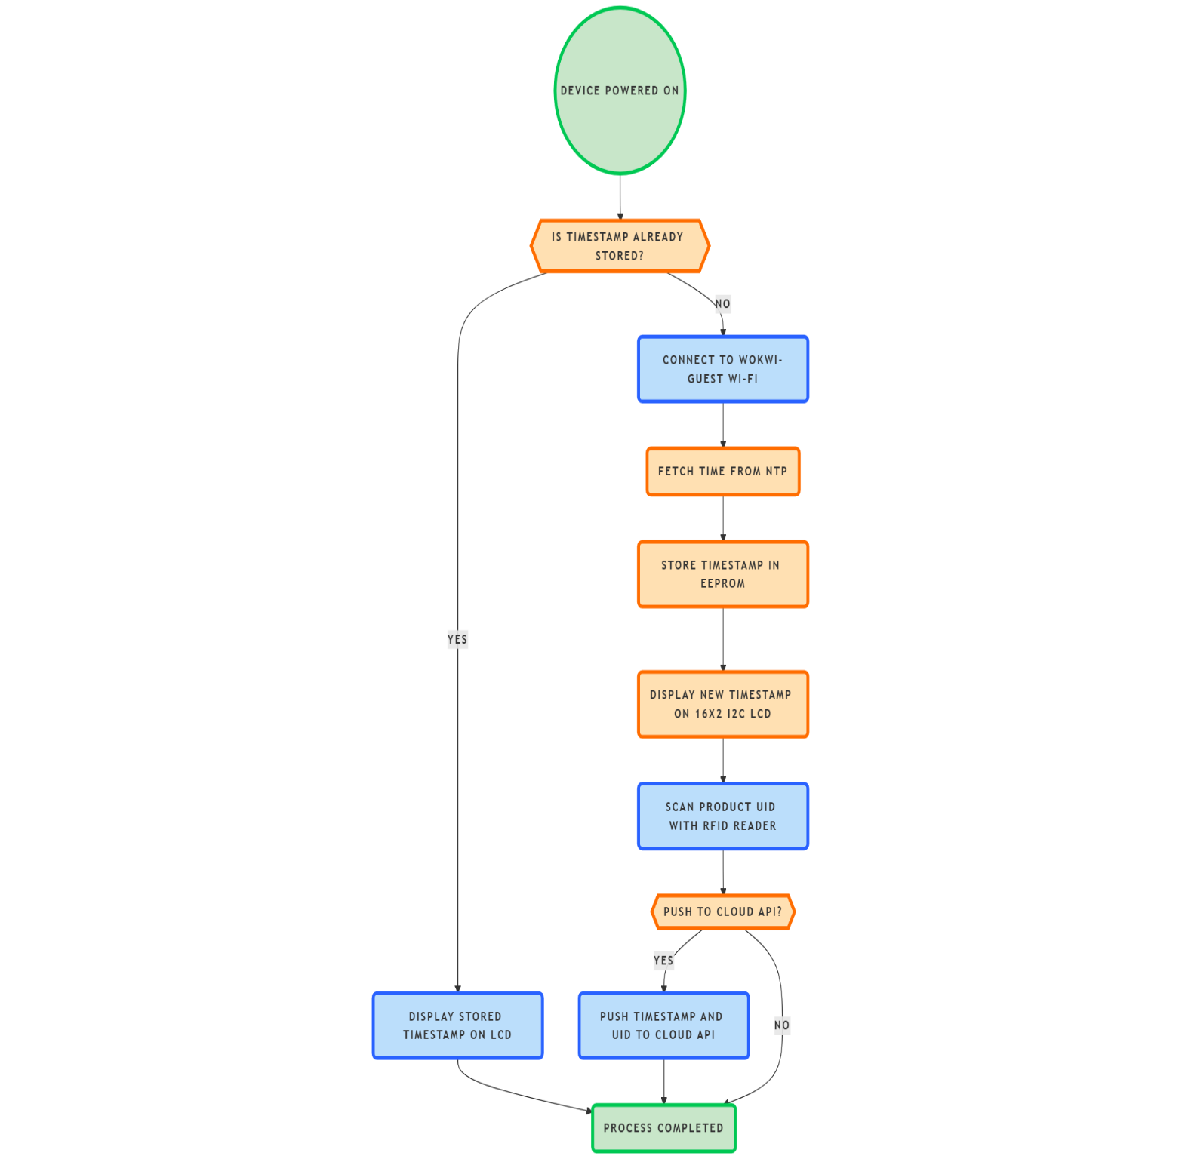

Wokwi Online Simulation

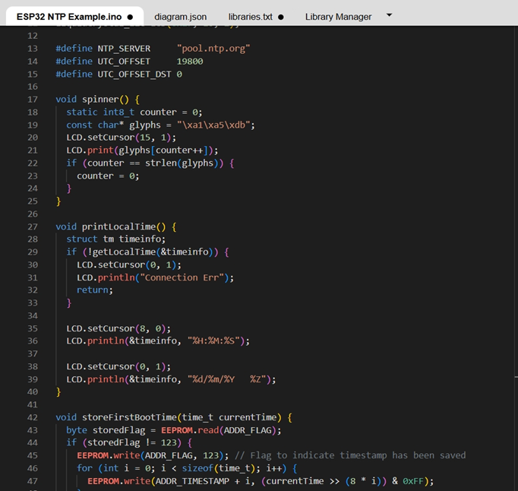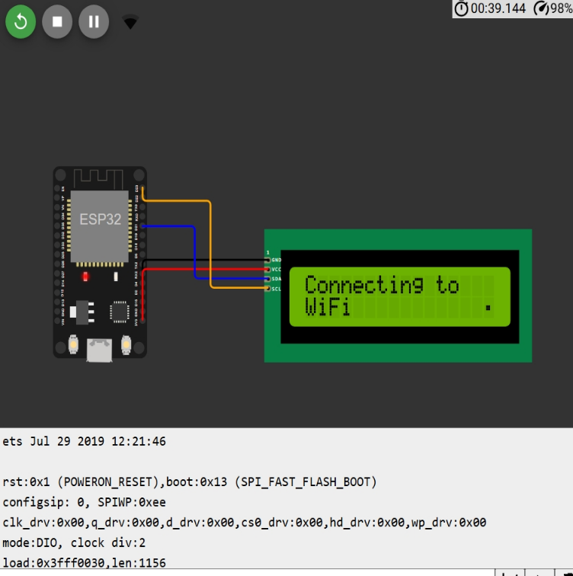

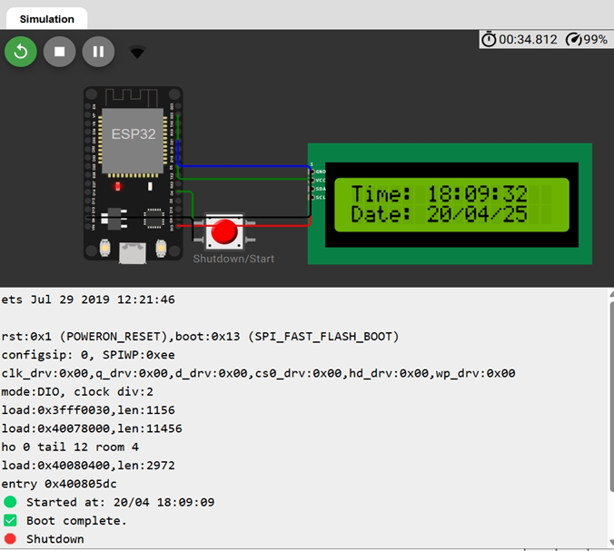

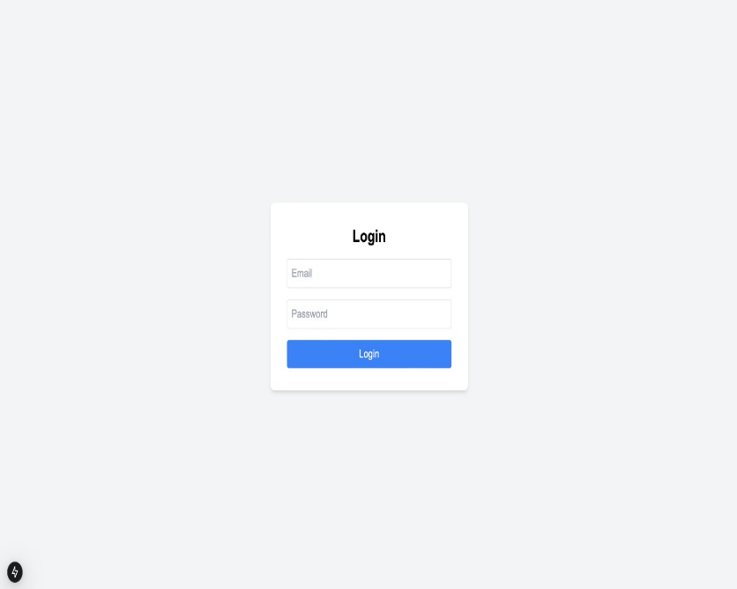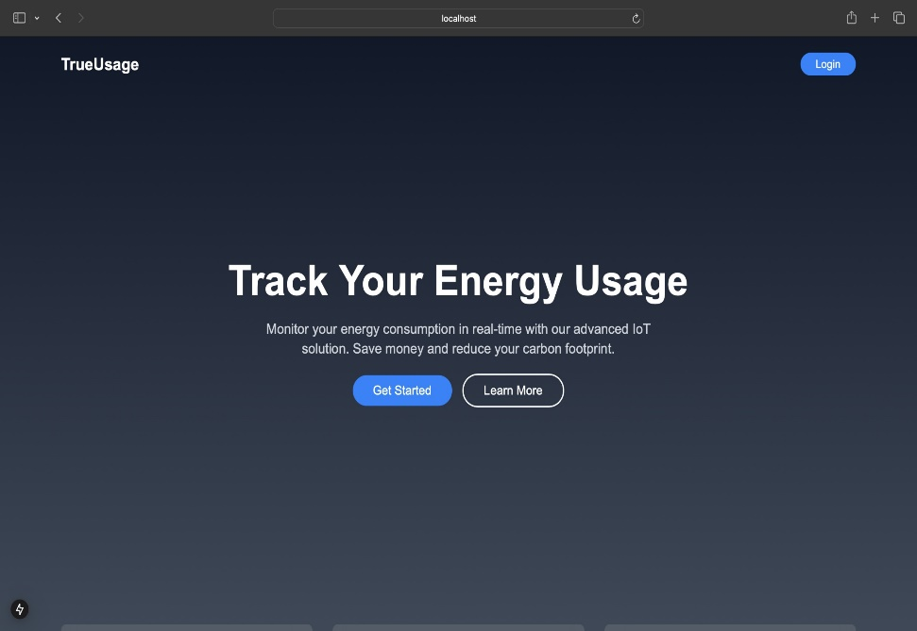UI Mockup

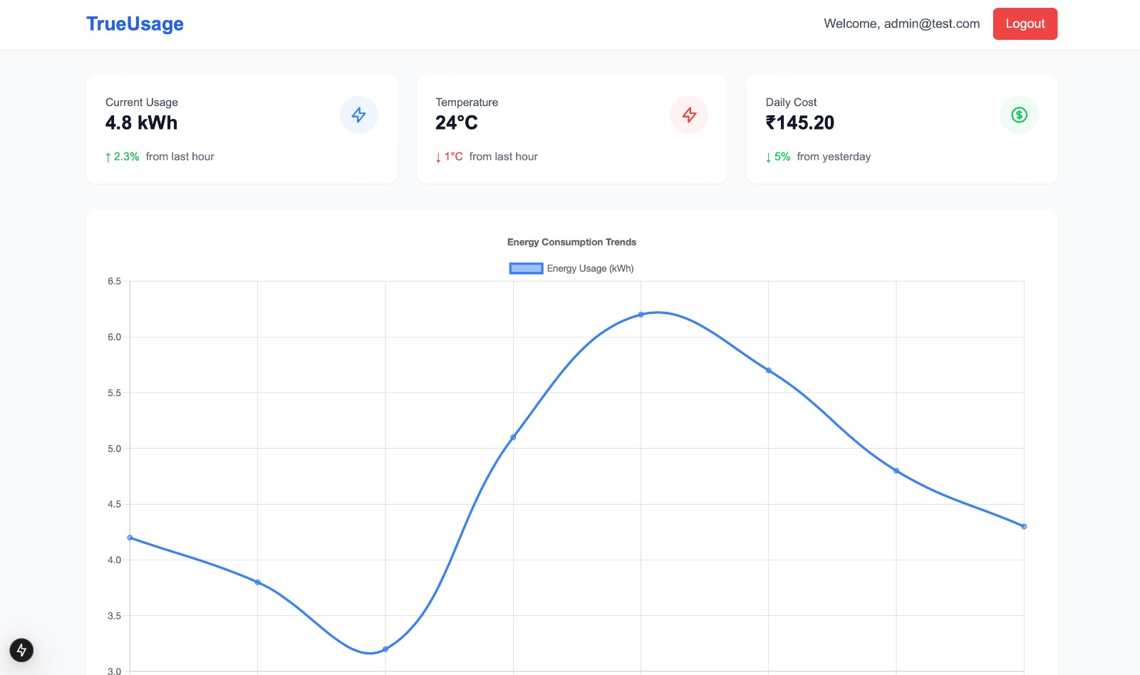

**References**

ESP32 Arduino Core Documentation  
  
Wokwi ESP32 Simulator Platform  
  
NTP Server Pool Project (pool.ntp.org)  
  
RC522 RFID Reader Datasheet & Documentation  
  
Arduino EEPROM Library and Usage Reference

**Links or details about the other artifacts of the project**

GitHub Repo : <https://github.com/Vikhyat02GIT/TRUEUSAGE-WEB>  
  
Wokwi Simulation Link : <https://wokwi.com/projects/428669343726189569>